AP Biology- Unit 3: Ch 8 Name _____________
Photosynthesis Study Guide
Intro and 8.1

- Label the diagram below.
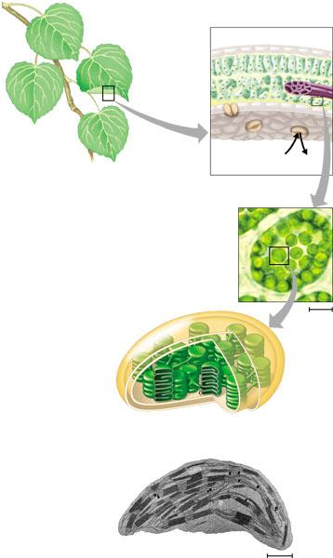
- Use the diagram to label and identify the two broad stages of photosynthesis.
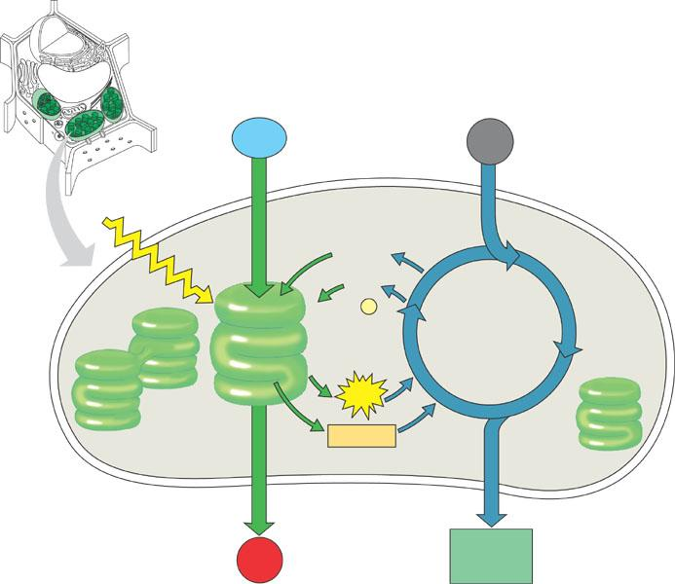

8.2 Reading

- What is a photon?
- Why are leaves green?
- What is the difference between an absorption spectra and action spectrum?
- What happens to chlorophyll when it is hit by light? How does this relate to potential energy?
- Identify the following:

  - Photosystem 2 –

  - Photosystem 1 –

  - Reaction center --

- How is noncyclic electron flow the same AND different from cyclic flow?

- Compare AND contrast chemiosmosis in mitochondria and chloroplasts.
- Label the diagram below to summarize the activities in the light reactions of photosynthesis.
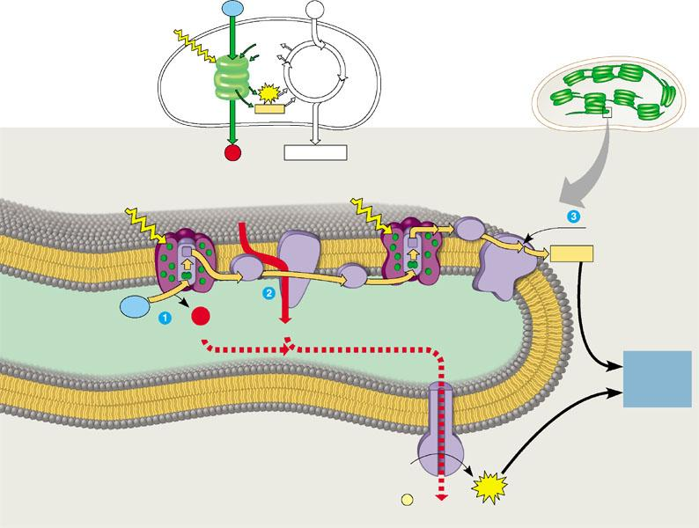
Section 8.3
- Explain the purpose of the Calvin cycle.

- Describe each step listed below:

  - Carbon fixation

  - Reduction

  - Regeneration

- Why did plants need to evolve adaptations for hot, arid climates?

- What is the enzyme that starts the Calvin cycle and how does it work?

Section 8.4

- Why is photorespiration such a “waste”?

- What are CAM plants and what is their “advantage”?

- Use the diagram below to summarize the activities of photosynthesis.
