AP Biology

Unit 5: Chapter 15 Reading Guide

Concept 15.1

1. What is an operon? What types of organism has operons?

2. List the three components of an operon, and explain the role of each one.

3. How does a repressor protein work?

4. What are regulatory genes?

5. Explain how repressible operons function. What is the role of the corepressor?

6. Name an example of a repressible operon.

7. Explain how inducible operons function. What is the role of the inducer?

8. Name an example of an inducible operon.

9. Label this sketch of an operon with the following terms:

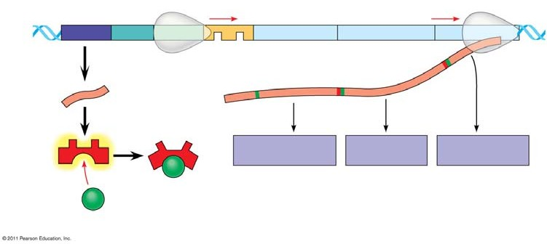
- operon genes

- operon

- RNA polymerase

- mRNA

- repressor protein

- operator

- promoter

- regulatory gene

- inducer

10. Even though all the cells of an organism have the same genes, there is differential gene expression. What does this mean?

11. Explain how the following modifications regulate gene expression:

- DNA methylation

- Histone acetylation

12. Define epigenetic inheritance.

13. On the diagram below, label the following: TATA box, promoter, gene, enhancer, activators, transcription factors, transcription initiation complex, RNA polymerase, and DNA. Explain how enhancers and activators interact with transcription factors to affect gene expression.

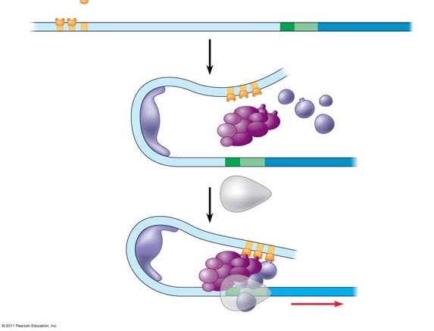Explanation

14. Prokaryotes coordinate the control of related genes through operons. However, eukaryotes do not have operons. Explain how eukaryotes coordinate the transcription of functionally related genes.

15. What are microRNAs (miRNAs)? What is their role?

16. What are small interfering RNAs (siRNAs)?

Concept 15.4

17. What three processes lead to the transformation of a zygote into the organism?

18. Explain what occurs in cell differentiation and morphogenesis.

19. Explain how the following control differentiation and morphogenesis.

- Cytoplasmic determinants

- Inductive signals

20. What is meant by determination? Explain what this means within an embryonic cell.

21. What is pattern formation?

22. What is controlled by homeotic genes?

23. What is the role of morphogens in pattern formation?

Concept 15.5

24. Contrast oncogenes and proto-oncogenes.
25. Refer to Figure 15.23. What are the three mechanisms for converting a proto-oncogene to an oncogene?

1.

2.

3.

26. What is the connection between tumor-suppressor genes and cancer?

27. How is the ras gene involved in cancer?

28. The p53 gene has been called the “guardian angel of the genome.” What are the 4 main ways in which p53 helps to prevent uncontrolled cell growth?

1.

2.

3.

4.

29. Explain the multistep model of cancer development by using the specific example of colorectal cancer. The figure below may be labeled to help in your explanation.

