AP Biology- Cellular Respiration Study Guide
Unit 3: Ch 7

- Compare the two catabolic pathways:
  - Fermentation

  - Cellular respiration
- Use the following terms correctly in a sentence: redox reactions, oxidation, reduction, reducing agent and oxidizing agent.
- Why is being “reduced” equivalent to having a greater potential energy?
- In cellular respiration, what is being oxidized and what is being reduced?

- Explain the use of coenzymes NAD+ and FAD+
- Why is having electron transport chains an advantage to living systems?

- What are the three stages of aerobic cellular respiration?

- What is substrate-level phosphorylation?

- Complete the chart below re: glycolysis
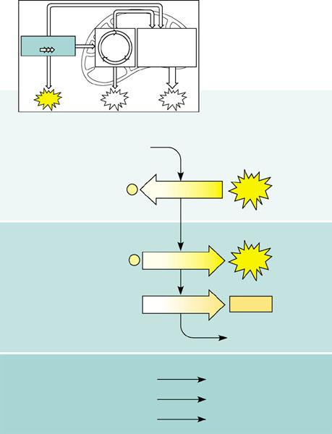

- Describe the transition reaction converting pyruvate to acetyl coA.
- Regarding the Kreb’ cycle, where does the C “go” that is removed?

- What is happening when NAD+ 🡪 NADH + H+?
- What is oxidative phosphorylation and where does it occur during respiration?

- What is chemiosmosis and apply it to the diagram below.
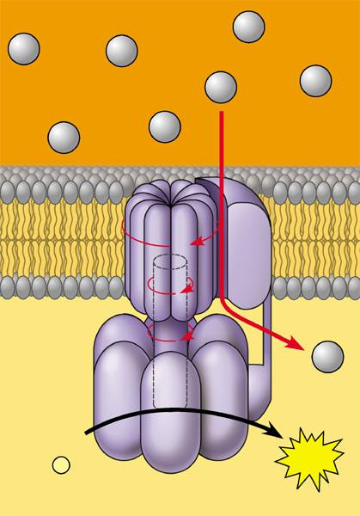
- Label the diagram below of the activities occurring on the ECT.
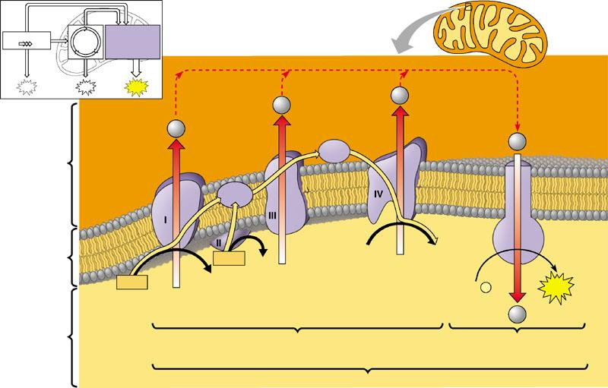
- Complete the summary diagram of cellular respiration.
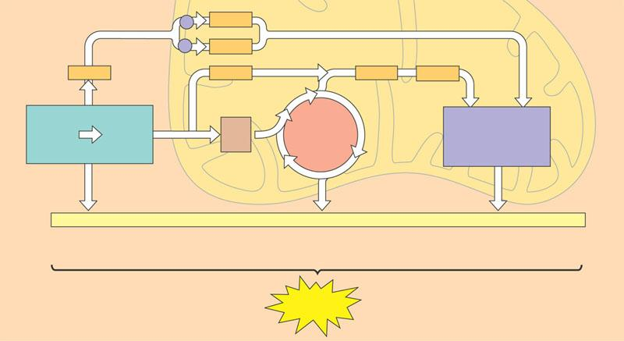
- Does aerobic cellular respiration happen in prokaryotic organisms – if yes – where?
- What is the overall purpose of fermentation? Why does it have to occur?
- What is a facultative anaerobe?
- What is the evolutionary significance of glycolysis?

- Why do fats provide a little more than twice as many calories per gram as compared to carbohydrates or proteins? Hint: Think of the output of the Citric Acid Cycle.

