Chapter 22 and 23
Evolution Review

In a very large population, a quantitative trait has the following distribution pattern:

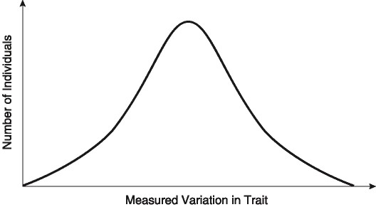

Figure 23.1

1) Which type of selection is true of the trait whose frequency distribution in a large population appears above?

2) If the curve shifts to the left or to the right, there is no gene flow, and the population size consequently increases over successive generations, then which type of selection is probably occurring?

You are studying three populations of birds. Population A has ten birds, of which one is brown (a recessive trait) and nine are red. Population B has 100 birds, of which ten are brown. Population C has 30 birds, and three of them are brown.

3) In which population would it be least likely that an accident would significantly alter the frequency of the brown allele?

A) Population A.
B) Population B.
C) Population C.
D) They are all the same.
E) It is impossible to tell from the information given.

4) In which population is the frequency of the allele for brown feathers highest?
A) Population A.
B) Population B.
C) Population C.
D) They are all the same.
E) It is impossible to tell from the information given.

5) Which population is most likely to be subject to the bottleneck effect?
A) Population A.
B) Population B.
C) Population C.
D) They are all the same.
E) It is impossible to tell from the information given.

6) Fossil evidence indicates that horses have gradually increased in size over geologic time. Which type of selection best describes this?

7) What is artificial selection and give an example?

8) Heterozygote advantage should be most closely linked to which type of selection?

In the year 2500, five male space colonists and five female space colonists (all unrelated to each other) settle on an uninhabited Earthlike planet in the Andromeda galaxy. The colonists and their offspring randomly mate for generations. All ten of the original colonists had free earlobes, and two were heterozygous for that trait. The allele for free earlobes is dominant to the allele for attached earlobes.

9) What is the allele frequency in the founding population?

10) If one assumes that Hardy-Weinberg equilibrium applies to the population of colonists on this planet, about how many people will have attached earlobes when the planet's population reaches 10,000?

11. In a hypothetical population of 1,000 people, tests of blood-type genes show that 160 have the genotype AA, 480 have the genotype AB, and 360 have the genotype BB. What is the frequency of each allele? Under Hardy Weinberg conditions what would be the number of AB individuals if the population was 4000?

12) In peas, a gene controls flower color such that R = purple and r = white. In an isolated pea patch, there are 36 purple-flowering plants and 64 white-flowering plants. Assuming Hardy-Weinberg equilibrium, what is the value of q for this population?

13) Which is a true statement concerning genetic variation?
A) It arises in response to changes in the environment.
B) It is created by the direct action of natural selection.
C) It must be present in a population before natural selection can act upon the population.
D) A population that has a higher average heterozygosity has less genetic variation than one with a larger average heterozygosity.
E) It tends to be reduced by the processes involved when diploid organisms produce gametes.

14. What is genetic drift? Give two examples of genetic drift and differentiate between each.
15. Differentiate between Darwin and Lamark’s views on heritable traits.

16. Why is Charles Darwin noted for his work in natural selection and evolution? (What was he first to do?)

17. What are the principles guiding the idea of natural selection?
-

18. If two modern organisms are distantly related in an evolutionary sense, what does this mean?

19. Give examples and describe homologous structures between 2 organisms.

20. Which piece of evidence most strongly supports the common origin of all life on Earth?

21. What is the smallest entity that can evolve?

