Nervous System Guided Reading Questions

- Compare and contrast the central and peripheral nervous systems.

- Differentiate between sensory neurons, interneurons, motor neurons, and effector cells.

- Describe the basic pathway of information flow through neurons that cause you to turn your head when someone calls your name.

- More primitive invertebrates such as jellyfish possess a nerve net. Which part of the neural pathway is missing?

- How would severing an axon affect the flow of information in a neuron? Explain.

- Differentiate between a resting potential and a threshold stimulus. What happens when a threshold stimulus is reached?

- Using the image below, use arrows and describe in detail how an action potential moves form one neuron to another neuron.
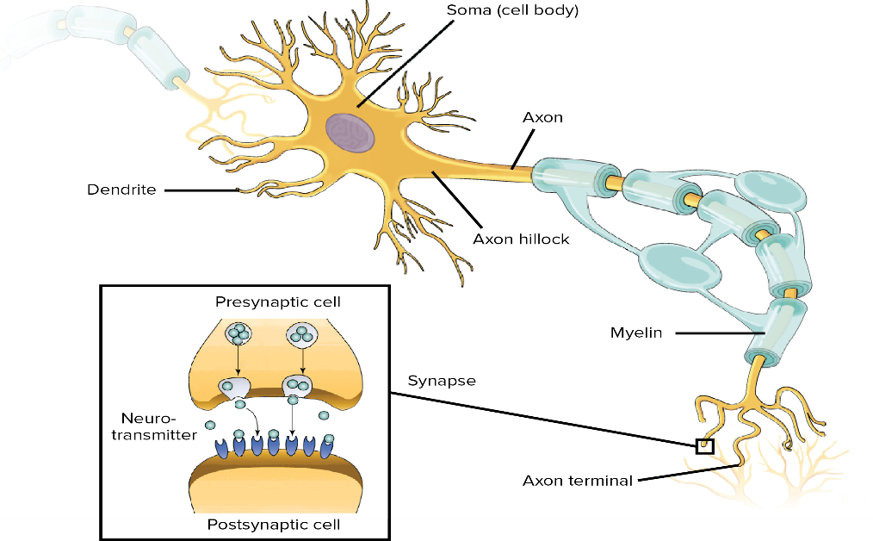

- Does an axon with a larger or smaller diameter conduct an impulse faster? Why?

- Diagram an action potential as it travels the length of an axon. Be sure to include Na+ and K+ concentrations and movements as the impulse moves along the axon.

- Why does is the term “salty banana” used to describe a neuron at resting potential?

- What is a synapse? How does is the action potential from the pre-synaptic neuron passed to the post-synaptic neuron?

- What would be the effect of a drug that causes potassium to leak out of a neuron?

